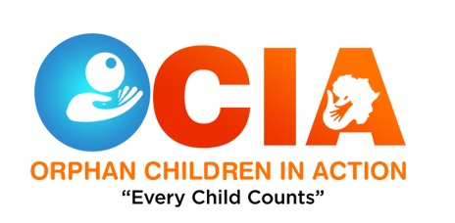

Volunteers’ Code of Conduct

& Responsibilities
You Must:

- Be honest at all times

- Be committed to the organisation

- Carry out agreed tasks

- Respect Confidentiality / discretion

- Follow health and safety procedures

- Follow the organisational code of conduct

- Abide by set procedures

- Exchange Information (regular contact with organisation)

- Be reliable

- Carry out the voluntary commitments in a way, which corresponds to the aims and values of Ocia.

- Volunteer within agreed guidelines and remits.

- Respect confidentiality.

- Respect other volunteers, service users and staff.

- Respect the human rights of others.

- Carry out the voluntary commitments with regard to the health and safety of others.

- Attend training, support sessions, review meetings etc.

- Ensure the safety and well-being of Ocian’s at all times whilst in your care

- See the Ocian’s on a regular basis, usually twice per month for 2 – 3hours each time.

- Keep Ocia informed of the number and type of activities participated in during the month and send in your monthly reports.

- Seek prior permission from relevant parties before doing anything outwith the norm, i.e. long distance journeys out with Aberdeen or activities involving an element of risk such as snowboarding, skiing etc.

You must not:

- Take Ocian’s to your home. Ask for overnight stays or to take your child on holiday.

- Involve other adults in Ocia. Partners and/or family members and/or friends who are likely to have contact with the child on a regular/semi-regular basis must be PVG checked and approved by Ocia.

- Leave the Ocian’s alone at any time or with any other adult.

- Ever become over-involved with a Ocian’s or their family

- Over-commit yourself.

- Accept gifts from the child or the family or handle money given for the child to spend

- Smoke while in the child’s company

- Consume alcohol while in the child’s company

Reviewed 16/06/20 | Next Review Date 19/08/21
Enock Kagimu | Added information

